**DAILY ONLINE ACTIVITIES SUMMARY**

|  |  |  |  |  |  |  |  |  |
| --- | --- | --- | --- | --- | --- | --- | --- | --- |
| **Date:** | **20/6/2020** | | | | | **Name:** | **Banish M G** | |
| **Sem & Sec** | **8th Sem** | | | | | **USN:** | **4AL16CS20** | |
| **Online Test Summary** | | | | | | | | |
| **Subject** | | **----** | | | | | | |
| **Max. Marks** | | **----** | | **Score** | | | **-----** | |
| **Certification Course Summary** | | | | | | | | |
| **Course** | **Python for data science** | | | | | | | |
| **Certificate Provider** | | | **udemy** | | **Duration** | | | **23hrs** |
| **Coding Challenges** | | | | | | | | |
| **Problem Statement:**  Write a C Program to rotate an array by K positions | | | | | | | | |
| **Status:COMPLETED** | | | | | | | | |
| **Uploaded the report in Github** | | | | | **yes** | | | |
| **If yes Repository name** | | | | | **Banish_MG** | | | |
| **Uploaded the report in slack** | | | | | **yes** | | | |

Online Test Details: (Attach the snapshot and briefly write the report for the same)

Certification Course Details: (Attach the snapshot and briefly write the report for the same)

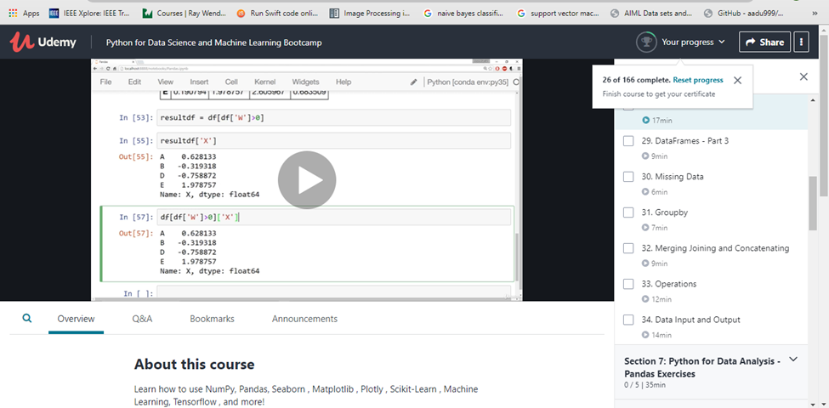

Coding Challenges Details: (Attach the snapshot and briefly write the report for the same)

#include <stdio.h>

void rotate(int arr[], int n)

{

int x = arr[n-1], i;

for (i = n-1; i > 0; i--)

arr[i] = arr[i-1];

arr[0] = x;

}

int main()

{

int arr[10], n, k, i, j;

printf("Enter the no. of elements: ");

scanf("%d", &n);

printf("Enter the elements: ");

for (i = 0; i < n; i++)

scanf("%d", &arr[i]);

printf("Enter the no. of times to rotate: ");

scanf("%d", &k);

for(j = 0; j < k; j++)

{

rotate(arr, n);

}

for (i = 0; i < n; i++)

printf("Element at index %d: %d\n", i+1, arr[i]);

return 0;

}